Patron Saint Project---- Due August 26, 2021
Step 1: Choose A patron saint for the year
Step 2: Do some research on your chosen saint:
- What did they look like?
- When/where did they live?
- What are they the patron saint of/ WHY?
- What was their childhood like?
- What hardships did they endure?
Step 3: Create a holy card of your patron saint for the year:
- Create a 4x6 holy card
- Draw (Not print out) your patron on one side
- Compose a prayer of at least 4 complete sentences on the opposite side asking this saint to help you in some specific way during this school year.
Step 4: When you find yourself needing a little extra help, ask that saint to help you; spend time this year getting to know your patron.
You will be graded with the following rubric:
- Creativity/Presentation- do your best work to create a likeness of the saint. This should not be copied. This is your rendition of the saint.
(15 points)
- Clarity/Grammar/ Complete Sentences for the prayer (15 points)
- Three-minute class presentation- highlights about your saint (15 points)
Total possible: 45 points
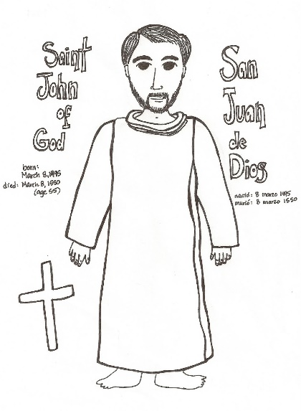
This Photo by Unknown Author is licensed under CC BY-NC-ND

